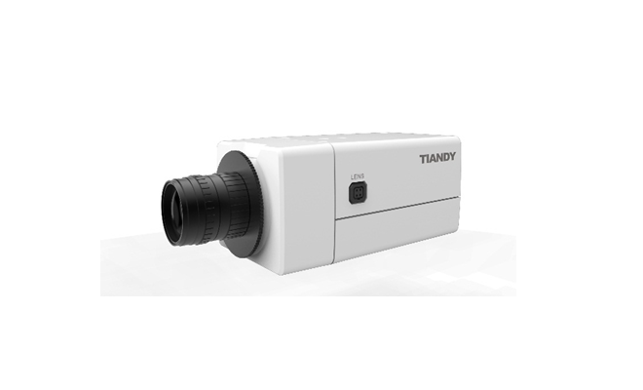

Features
• H.265 Codec
• Up to 2048X1536 High Resolution
• 50Hz: 25fps (2048×1536), 50fps (1920×1080)
• 60Hz: 30fps (2048×1536), 60fps (1920×1080)
• WDR, 3D DNR, HLC
• Triple Streams
• Smart VQD(Video Quality Diagnosis)
• Smart Facial Detection
• 19 kinds of IVA functions
• Defog
• On-board Storage, up to 64GB
• TVS 6000V Protection

Specification
Image Sensor | 1/2.8″ Sony Exmor CMOS
Core Processor | Cortex A7 Architecture Processor
Operating System | Embedded Linux
Signal System | PAL/NTSC
Min. Illumination | Color: 0.05 Lux @(F1.2, AGC ON)
Min. Illumination | B/W: 0.01Lux @(F1.2, AGC ON); 0 Lux with IR
Shutter Time | 1/100000s～1s
Lens | N/A
Lens Mount | C/CS
Auto Iris | Y
Day& Night | Dual ICR
Wide Dynamic Range | 120 dB
Digital Noise Reduction | 3D DNR
Compression Standard
Video Compression | H.265/H.264/MJPEG
Bit Rate | 32Kbps~16Mbps
Audio Compression | G.711/G.726/ADPCM
Bit Rate | 8K~48Kbps
Image
Max. Image Resolution | 2048×1536
Frame Rate | 50Hz: 25fps (2048×1536), 50fps (1920×1080)
Frame Rate | 60Hz: 30fps (2048×1536), 60fps (1920×1080)
Triple Stream | Mainstream: 3MP(2048×1536)
Triple Stream | Substream: D1(704*576)
Triple Stream | 3rd stream: D1(704*576)
Image Settings | Configurable Brightness, Saturation, Contrast, Flip Mode
HLC | Y
Smart Defog | Y
Corridor | Y
EIS | Y
ROI | 4 Zones
Privacy Mask | 4 Zones
Picture Overlay | 200 × 200, BMP 24bit, Zone Configurable
Network
Browser | IE 7+, Chrome 18 +, Firefox 5.0 +
Network Storage | NAS
Video Analytics | Tripwire/Perimeter/Facial detection/People Counting/ Missing&Foreign object/Crowd/Loitering/Fast Moving/Parking/Off-position/Blurred Image/Audio Offline/Screaming Detection
Alarm Trigger | Motion Detection/IP Conflict/MAC Conflict/Port Alarm
Protocols | TCP/IP/ICMP/HTTP/HTTPS/FTP/DHCP/DNS/  DDNS/RTP/RTSP/RTCP/PPPoE/NTP/UPnP/  SMTP/SNMP/IGMP/802.1X/QoS/IPv6/Bonjour
User Permission | 4 Level/8 Users
System Compatibility | ONVIF (Profile S), SDK
Interface
Audio Input | 1-ch 3.5 mm Audio Interface, MIC IN/LINE IN
Audio Output | 1-ch 3.5mm Audio Interface (Line Level, 600 Ω)
Communication Interface | 1-ch RJ45 10M / 100M Ethernet Interface and 1-ch RS-485 Interface
Alarm Input | 2-ch
Alarm Output | 1-ch
Video Output | 1-ch Vp-p Composite Output (75 Ω, BNC)
On-board storage | Built-in Micro SD/SDHC/SDXC Card Slot, up to 64 GB
Extension | N/A
General
Operating Conditions | -35℃～60℃, 0～95% RHG
Power Supply | DC 12V±10% AC 24V±10%, PoE (802.3af)
Power Consumption | Max 4.5 W
Circuit Protection | TVS 6000V, Lightning/Surge 2000V Protection
Impact Protection | N/A
IR Range | N/A
IR LEDs | N/A
Dimensions | 145mm×71mm×58mm
Weight | 0.6kg (IP Camera Only); 0.8kg (with Packing Box)

Dimension
